**Final Project | INFO 1113 (S11)**

*Dr. Abhijit Sen*

November 28th, 2019

**“*A Seat to Eat”***

**Tanner Anderson – ID #100388860**

[*tanner.anderson@email.kpu.ca*](mailto:tanner.anderson@email.kpu.ca)

[*https://sites.google.com/view/tannerandersonproject1/home*](https://sites.google.com/view/tannerandersonproject1/home)

[*https://github.com/tanneranderson/FinalProject*](https://github.com/tanneranderson/FinalProject)

[*https://trello.com/b/comldZ44/final-project-info-1113*](https://trello.com/b/comldZ44/final-project-info-1113)

**Sahil Minhas – ID #100385673**

[*sahil.minhas@email.kpu.ca*](mailto:sahil.minhas@email.kpu.ca)

## [*https://sites.google.com/view/standalonesoftware/home*](https://sites.google.com/view/standalonesoftware/home)

## *<https://github.com/sahilrajput2921/FinalProject>*

## [*https://trello.com/b/kprXOFD9/finalprojectinfo-1113*](https://trello.com/b/kprXOFD9/finalprojectinfo-1113)

## Jayden Cang – ID #100389370

[*jayden.cang@email.kpu.ca*](mailto:jayden.cang@email.kpu.ca)

## [*https://sites.google.com/view/info1113-jaydencang*](https://sites.google.com/view/info1113-jaydencang)

## [*https://github.com/jaydenc0/FinalProject*](https://github.com/jaydenc0/FinalProject)

[*https://trello.com/b/H5bUCKng/info-1113*](https://trello.com/b/H5bUCKng/info-1113)

## Table of Contents

## Introduction ………………………………… 3

## Executive Report ………………………….. 4

## Class Diagram …………………………….. 5

## Sequence Diagram ……………………….. 6

## Use Case Diagram ……………………….. 7

## Use Case Description ……………………. 8

## Use Case Description (Tanner) ……. 8

## Use Case Description (Sahil) ………. 9

## Use Case Description (Jayden) ……. 10

## Prototype Examples ……………………… 11-16

## Problems Faced ………………………….. 17

## Conclusion ………………………………… 18

## Work Cited ………………………………… 19

## Introduction

## Enjoy a night out filled with fun and flavor, thanks to *“A Seat to Eat”,* the real time saver. Who has the time to wait in line? Instead, look at the quickest place for you to dine. In the mood for a certain food? There are many filters to be viewed. Feeling fancy and craving fish out the sea? We’ll find you what you want, our users agree. No need to worry when it comes to planning your night. You will find your new favourite restaurant with one single bite. Provide us with a range or given location, and we’ll find you restaurants near, far or across the nation. You may also leave reviews to earn rewards, it’s amazing what you can put them towards. View restaurant specials for the desired day, with deals these good, it will make you want to stay. So, what are you waiting for? give yourself a treat. But why not make the experience easier, with “*A Seat to Eat”.*

## Executive Report

## They say time flies when you’re having fun, so you better make the most of it. Yet somehow, we still find ourselves wasting away our precious time. Well, we have the answer. With our application, it will allow you to have the most enjoyable experience while dining out. Introducing your new favourite application, *“A Seat to Eat”.* Our philosophy is for the customers looking to dine out and make the most out of their precious time and spend it where it matters most, around the dinner table. This application is completely free and jam-packed with many features. Such as, viewing wait times for your favourite local restaurants, getting an inside scoop on daily specials and the opportunity to earn the rewards that you deserve. Craving some food but not sure what you want? Feel free to view any restaurant’s menu with ease. By using our application, not only will you be able to access the menu and make reservations, but you may also view and submit feedback on your experience. By doing so, this will allow you to earn rewards for future dining experiences. So, what are you waiting for? Stop wasting time and have an amazing night worth remembering.

## Class Diagram

## Figure 3

## 

## Sequence Diagram

## Figure 4

## 

## Use Case Diagram

## Figure 5.1

## Use Case Description

## Figure 6.1 *Made by Tanner Anderson*

|  |
| --- |
| **Use Case Title:** View Daily Specials at restaurants |
| **Primary Actor:** Customer |
| **Level:** Kite |
| **Stakeholders:** Customer, Restaurants |
| **Precondition:** Customer must create a free account |
| **Minimal Guarantee:** Customer complemented with voucher for future use |
| **Success Guarantees:** View deals on select days in order to save money |
| **Trigger:** Customer accesses daily specials page within application |
| **Main Successes Scenario:**   1. Restaurant will post daily specials as well upon uploading the menu. 2. Customer will open the application and input the desired day they wish to view specials. 3. Customer will input a location radius for restaurants in desired area. 4. Customer has the option to be able to select additional various filters (Sort Food Type, Sort Price Range) |
| **Extensions:**  1a. Application fails to load  1a1. Customer closes application  1a2. Customers reloads application  2a. Specific restaurant’s daily special is not available on desired day.  2a1. Customer contacts the restaurant.  2a2. The customer may be granted a voucher for the inconvenience from the restaurant.  2a3. Restaurant publishes an announcement to the daily specials page, apologizing.  2a4. The customer may view other restaurant deals on desired days. |

## 6. Use Case Description

## 6.3 Use Case Description

## A screenshot of a cell phone Description automatically generatedFigure 6.3 *Made by Jayden Cang*

## 7. Prototype Examples

## Figure 7.1

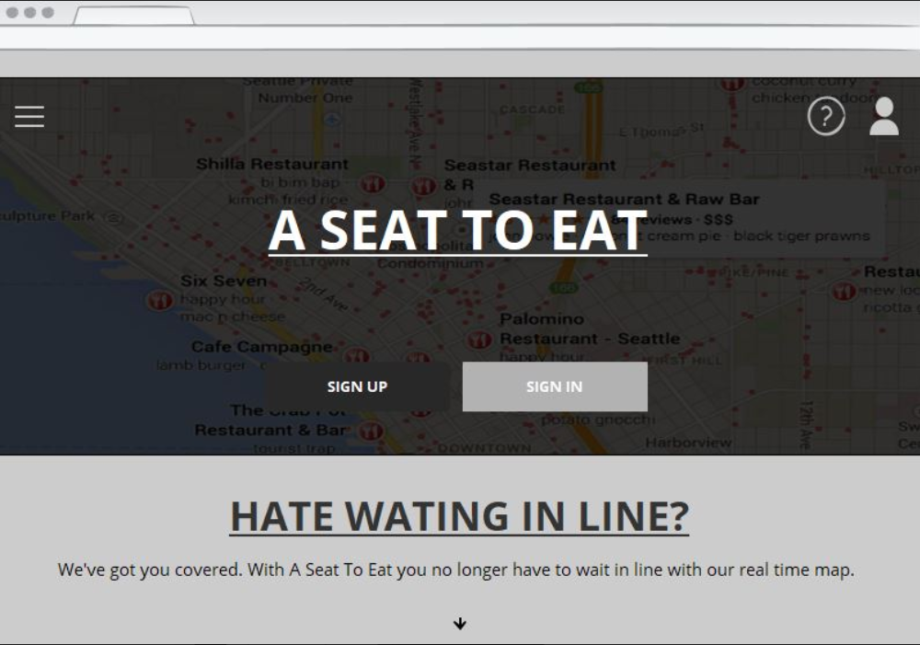

## Home Screen: Sign in/Sign up for Program.

## Prototype Examples

## Figure 7.2

## 

## Sign Up Screen: User selects sign up and has choice to sign up via email or Facebook, Twitter, Google.

## Prototype Examples

## Figure 7.3

## 

## Login Screen: Enter Username/Password

## (Login also with Facebook, Twitter, Google)

## Prototype Examples

## Figure 7.4

## 

## Main Screen for users: View Map of restaurants, Get choices for Filters.

## Prototype Examples

## Figure 7.5

## 

## Wait Times Updated/Loaded: View local wait times within radius (Green is quick service; Red is longer wait)

## Prototype Examples

## Figure 7.6

## 

## User has selected a restaurant: Display additional information on selected restaurant.

## Problems Faced

## Like many things in life, there are many hardships along the way. Whether it’s coming up with the next great idea, finding time to spend doing homework, or inputting all our great ideas into one single application, we did our best and we made it work. Not only did this group project help us socialize and voice our own opinions and ideas, but it brought us together and made us great friends for life. Without the projects and assignments assigned in this group setting, we may have never been able to connect and become the great friends which we are today.

## Conclusion

## In conclusion, not only will our application help many restaurants gain business and revenue due to more exposure from users. In fact, the users themselves will have a more enjoyable time in general, spending precious time and living it up on a night out has never been so easy thanks to “A Seat to Eat”. Download our app today, and we will make sure to always have a seat, for you to eat.

## Work Cited

## Just In Mind – Prototype Developer

## Abhijit Sen – Additional Resources

*Thank you for an amazing term and all the knowledge we have learned in such a short period of time. You are truly a gifted professor!*

* *Tanner, Sahil, Jayden*